**Primary Gameplay Mode**

The gameplay begins with the “Ori”, our hero, who starts its journey towards the elements. He has three paths with respect to three elements i.e. Water, Wind and Fire. He chose one path and started his search for the element into the forest.

**Challenges and Actions:**

The forest is full of danger due to dragons which are hurdles in the path of the character/hero and these dragons with respect to their element are the main challenges for the “Ori”. He must collect energy booster while going toward the element. These boosters will refill his energy while fighting with dragon. Finally, he reached to the respective element, but he has to fight with and kill the dragon who are guarding this element. After killing the dragon, he starts his journey toward second element. He also faces the same hurdles and reach to the element, but he has to kill the second dragon who is guarding the respective element. After killing that dragon, he starts his journey toward third and last element. After combatting with the dragons, “Ori” will get all the three elements. And after that, the gameplay will move to its ending part, “Ori” returns to “The Spirit Tree” and give him these elements. “The Spirit Tree” finally able to do magic and after doing so, the forest gain its greenery back and all the species again live a happy life.

**Model:**

We are using bitmap mode l. Bitmap files may be easily created from existing pixel data stored in an array in memory. Retrieving pixel data stored in a bitmap file may often be accomplished by using a set of coordinates that allows the data to be conceptualized as a grid.

**User Interface:**

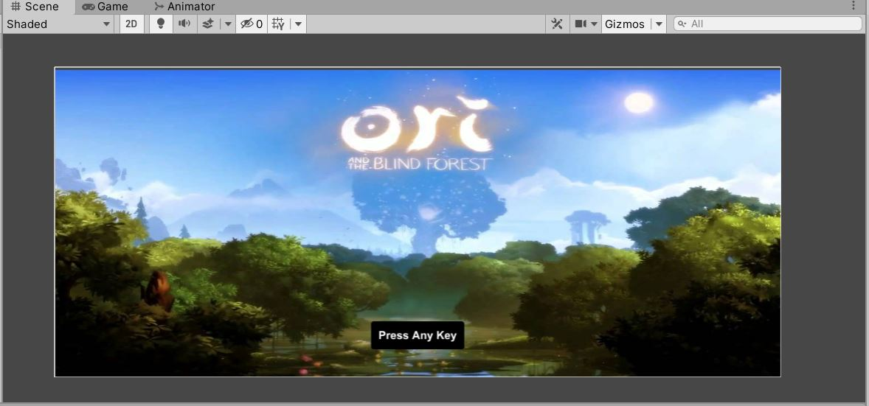

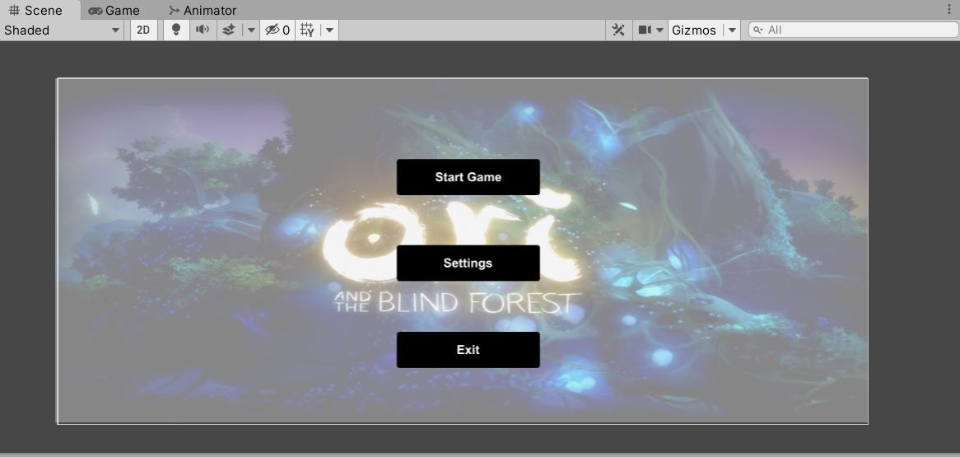

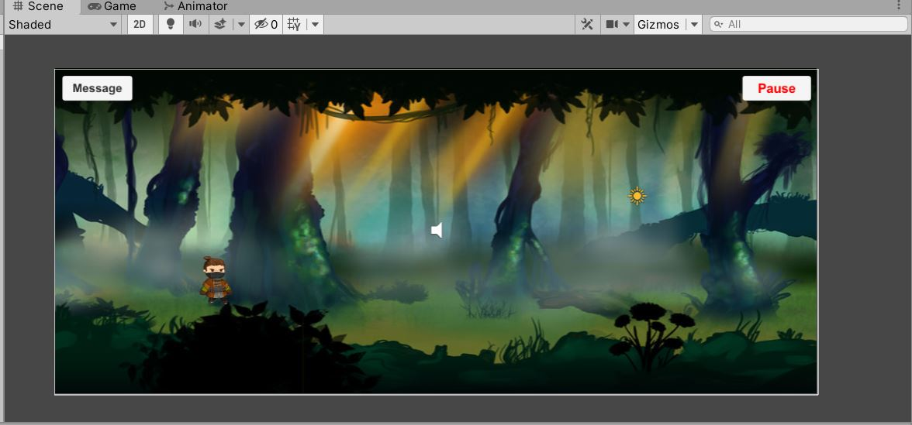

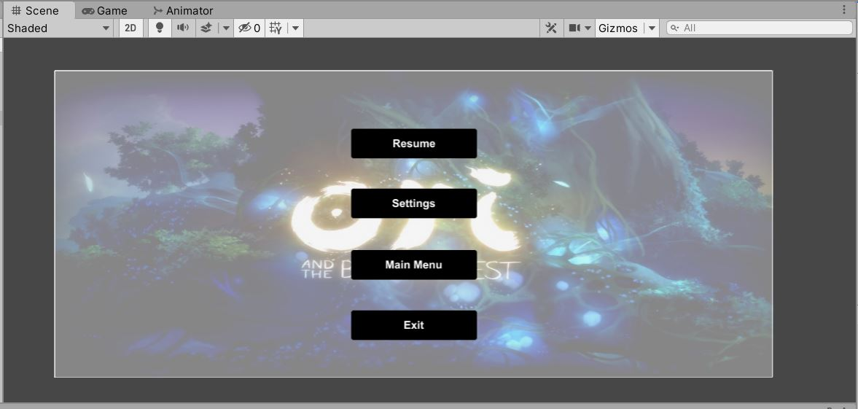

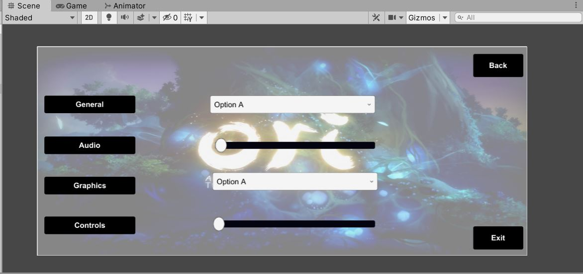

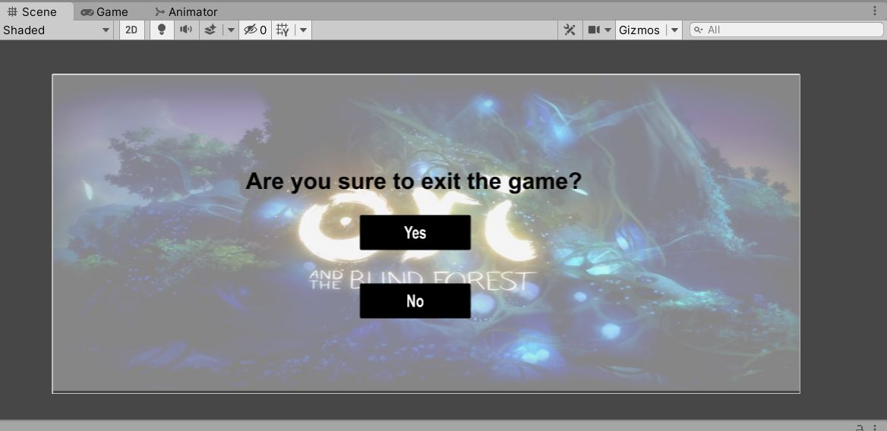

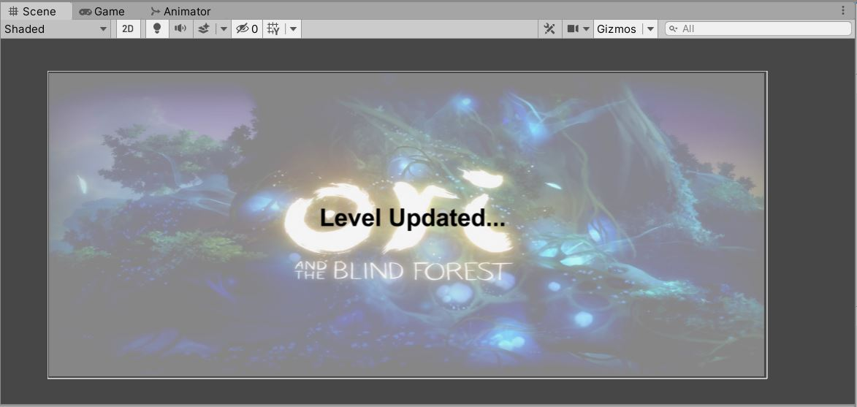

**Buttons and Menus:**

The game contains the followings buttons and corresponding menus:

* Welcome window contains **Press any key** button to go to main menu.
* Main Menu contains three buttons:
* **Start Game** (to main game)
* **Settings** (to settings menu)
* **Exit** (to exit confirmation window)
* Main screen of game contains two buttons:
* **Pause** (to pause menu)
* **Message** (to message window) (just added for testing purpose)
* Pause Menu contains four buttons:
* **Resume** (to main game)
* **Settings** (to settings menu)
* **Main Menu** (to main menu)
* **Exit** (to exit confirmation window)
* Settings Menu contains four options and two buttons:
* **General option** (for general controls e.g., player etc.)
* **Audio option** (for audio controls)
* **Graphics option** (for graphics controls)
* **Control option** (for other controls)
* **Back button** (to go back to respective menu)
* **Exit button** (to exit confirmation window)
* Exit confirmation window contains following:
* **Confirmation text**
* **Yes button** (to exit game)
* **No button** (to go back to respective window)